PARENT/GUARDIAN AUTHORISATION FORM

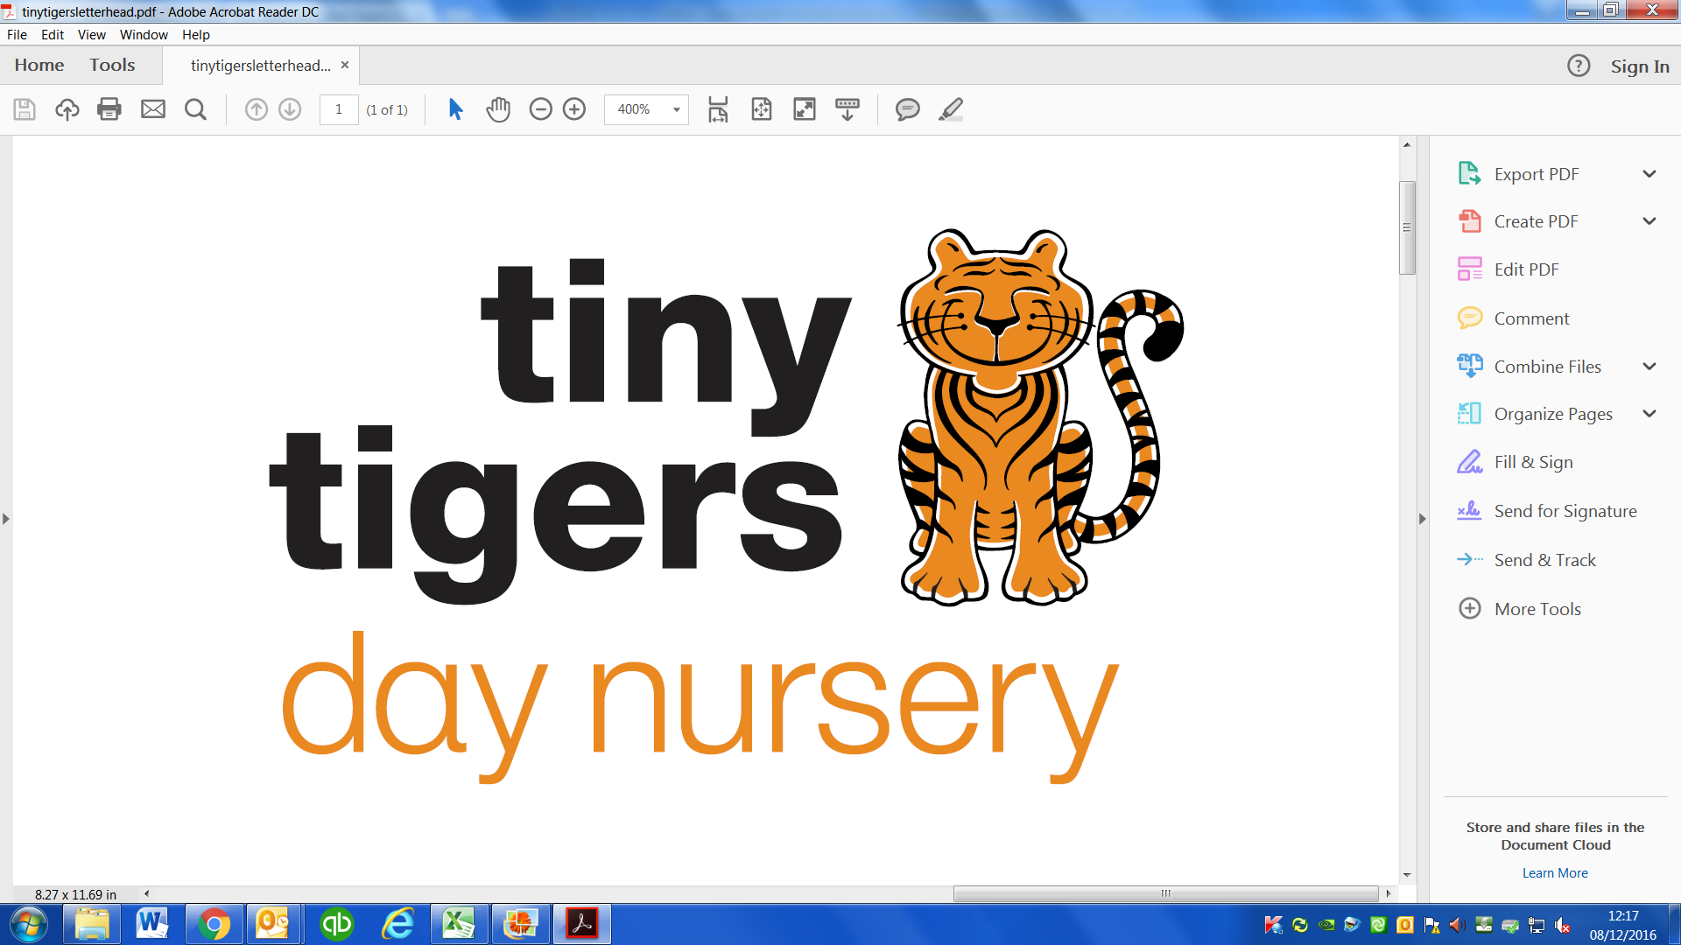
CHILD’S NAME: ________________________________________

PARENTS NAME: (print) _________________________________

DATE: _________________________________________________

AUTHORISATION FOR | PARENTAL RESPONSIBILITY SIGNATURE
RAISED TEMPERATURE
In an emergency I give permission for my child to have infant paracetamol suspension (e.g. calpol) for raised temperature.
URGENT MEDICAL TREATMENT
I give my consent to my child receiving any medical treatment which is urgently necessary.
TRANSPORT TO HOSPITAL
I hereby give permission for my child to be taken to hospital in an emergency.

PHOTOS
No child’s name or details will be attached to any photo. I hereby give permission for photos/videos of my child taken:-
By staff for use in displays, records of outings or future brochures/ websites/facebook
By an approved commercial photographer for pictures for my use
By the local press to accompany newspaper articles
OUTINGS & WALKS
During the year we would like to take the children out for local walks to link in with our current topics and projects. These outings are of great benefit to the children as they encourage the children’s sense of the world around them giving them the opportunity to learn new words, find out about new things and meet new friends, but most of all it is a fun activity.

If you are happy for us to take your child out while they are at nursery would you please sign.
SUN LOTIONS/CREAM/TOOTHPASTE
I give my consent for sun lotion to be applied to my child during hot weather. Due to the different types of skin we would ask you to provide a suitable sun screen for your child with their name clearly marked on the bottle. Please could you also provide a named tube of toothpaste and tub of nappy cream.

Please specify name of provided:-
TOOTHPASTE SUN CREAM NAPPY CREAM

PLASTERS
I give permission for plaster to be applied to an open wound should the need arise.
SHARE INFORMATION WITH HEALTH VISITOR
I give permission for Tiny Tigers to share information with my Health Visitor.
DATA PROTECTION
I/We consent to our data being used solely to enable the setting to provide care and education to our child/ren in partnership with us. The information will only be provided to third parties with our permission (unless abuse or neglect is suspected). We understand personal data held by the setting will be for specified purposes such as to enable us to be contacted in case of an emergency. We understand it is our responsibility to ensure the setting has up to date and accurate information about our contact details and anything else deemed significant. We understand these details will be kept for min of 3 years after our child leaves the setting.

